

BACHELOR OF COMPUTER APPLICATIONS

Introduction to Information Technology & PC Packages
(BCA –5000 T)

1

About Me


Name:
Ms. Sarika Purbia
Qualification:
BCA, MCA
Areas of Interest:
C, C++, Data Structure, MS Office, Data Mining, System Analysis and Design, Networking, ITPC

2

Learning Outcome of this Subject

- Learn basic information about the computer system.
- Acquire knowledge about computer hardware and computer software.
- Familiarize with the use of MS Windows, Internet and E-mail.
- Familiarize with the use of MS Office - MS Word, MS Excel & MS PowerPoint.

SYLLABUS

UNIT-I Computer Basics and its generations:
A Simple Model of a Computer Characteristics and classification of Computers Generations of Computers
Basic Applications of Computer
Components of Computer System Central Processing Unit (CPU) VDU, Keyboard and Mouse Other input/output Devices
Computer Memory organization and hierarchy
Concepts of Hardware and Software
Concept of Computing Data and Information Applications of ICT

SYLLABUS

UNIT-II Operating Systems
DOS, Windows and Linux Operating System

UNIT-III UNIT-IV

UNIT- V
Word Processing software
Using Spread Sheet and Presentations Making Small Presentation Introduction to Internet, WWW and
Web Browsers

REFERENCE BOOKS

- P .K. Sinha ,Fundamentals of Computers, BPB Publications
- Fundamental of Computers By R. Thareja, Oxford University Press.
- Introduction to Information Technology-ITL Education solutions limited, PEARSON.

What is a Computer?

Computer

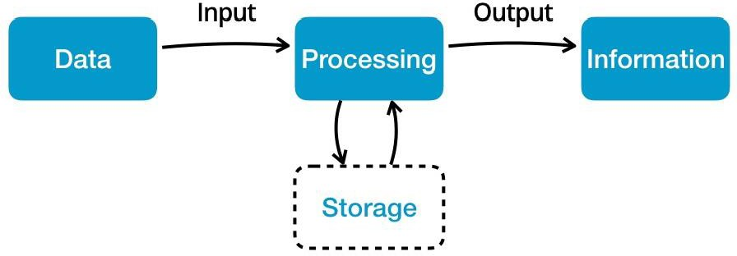

Father of Computer??

C= COMMONLY O=OPERATED M=MACHINE P=PARTICULARY U=USED FOR T=TRADE E=EDUCATION AND R=RESEACRH

Computer
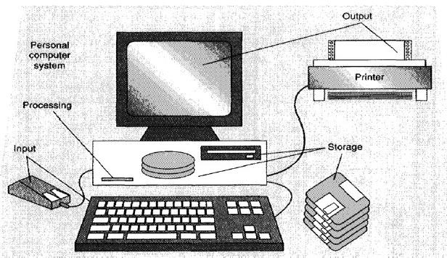
Model of Computer

Computer
- The word computer comes from the word “compute”, which means, “to calculate”
- Thereby, a computer is an electronic device that can perform arithmetic operations at high speed
- A computer is also called a data processor because it can store, process, and retrieve data whenever desired.

Block Diagram of Computer

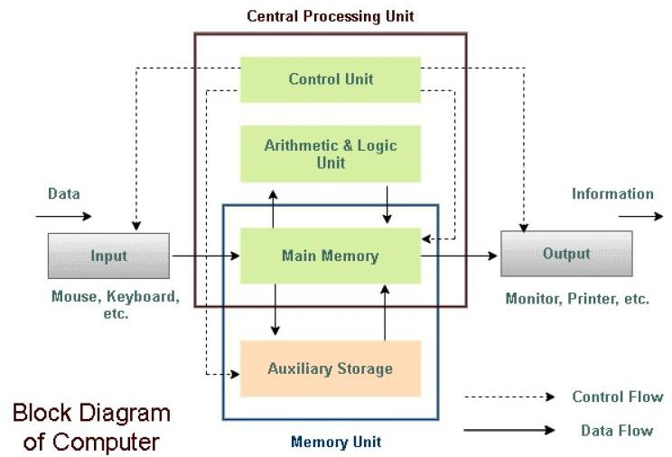

Block Diagram of Computer

- Mainly computer system consists of three parts as :
  - Input Devices, and
  - Output Devices.
  - Central Processing Unit (CPU),
  - Memory Unit

Working
- The data is entered through input devices such as the keyboard, mouse, etc.
- This set of instruction is processed by the CPU after getting the input by
the user, and
- Then the computer system produces the output with the help of output devices to the user, such as monitor, printer, etc.
- A large amount of data is stored in the computer memory with the help of primary and secondary storage devices.

Characteristics of Computers
- Speed: Computer can perform data processing jobs very fast, usually measured in microseconds (10-6), nanoseconds (10-9), and picoseconds (10-12)
- Accuracy: Accuracy of a computer is consistently high and the degree of its accuracy depends upon its design.

Computer errors caused due to incorrect input data or unreliable programs are often referred to as Garbage- In-Garbage-Out (GIGO)

Characteristics of Computers
- Diligence: Computer is free from monotony, tiredness, and lack of concentration. It can continuously work for hours without creating any error and without grumbling.
- Power of remembering : Computer can store and recall any amount of information because of its secondary storage capability. It forgets or looses certain information only when it is asked to do so.
- Versatility: Computer is capable of performing almost any task, if the task can be reduced to a finite series of logical steps.

Characteristics of Computers

Automation
Computer performs all the tasks automatically i.e. it performs tasks without manual intervention.

Storage
It can store huge amount data.

Characteristics of Computers

- No Feelings: Computers are devoid of emotions. Their judgment is based on the instructions given to them in the form of programs that are written by us (human beings).

Reliability
A computer is reliable as it gives consistent result for similar set of data i.e., if we give same set of input any number of times, we will get the same result.

Characteristics of Computers

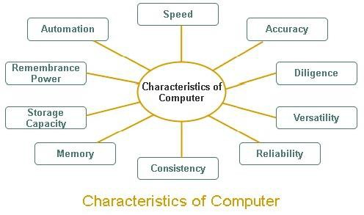

Limitations of Computer
- No I.Q.: Computers rely on human instructions and data. They cannot think or make decisions independently without programming.
- Lack of Creativity: While computers can generate content based on existing data, they do not possess true creativity or the ability to think outside the box like humans do.
- Security Vulnerabilities: Computers are susceptible to malware, hacking, and other security threats, which can compromise data integrity and privacy.

Classifications of Computer
We can classify the computers according to the following three criteria:
- Based on operating principles
- Based on applications/ purpose
- Based on size and capability

Based on Operating Principles
On the basis of operations performed computers can be classified into the following categories:
  - Analog computers
  - Digital computers
  - Hybrid computers

Analog, Digital and Hybrid Computers

  - Analog Computers :- The analog computers represent data in the form of continuous electrical signals having a specific magnitude. They are continuous in nature.
  - Digital Computers:- The digital computer is a type of computer that stores and processes data in the digital form.
  - Hybrid Computers :- The hybrid computer is a combination of analog computer and digital computer because it encompasses the best features of both these computers.
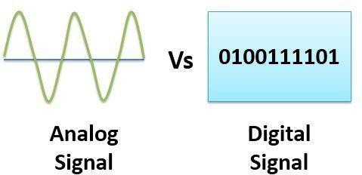
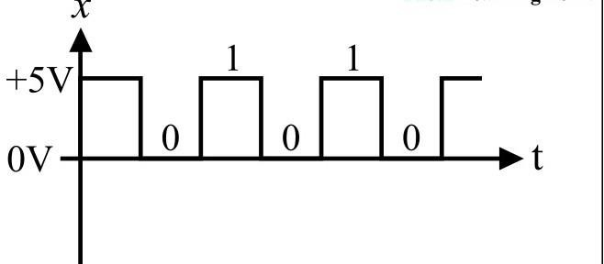

Based on Applications/ Purpose
On the basis of different applications or purposes, computers can be classified into the following categories:

    - General purpose computers

    - Special purpose computers

General & Special Purpose Computer
  - General purpose computers:- These are versatile computing device designed to perform a wide range of tasks and operations, rather than being specialized for a specific applications.
  - Special purpose computers:- They are designed in such a manner that they can perform only a specified task. The special purpose computers are not versatile and their speed and memory size depend on the task that is to be performed.

Based on Size and Capacity
On the basis of size and capability, computers can be classified into the following categories:
    - Microcomputers
    - Mini computers
    - Mainframe computers
    - Super computers

Microcomputers
A microcomputer is a small and cheap digital computer that is designed to be used by individuals.
Depending on the size, the microcomputer can be further classified into the following types:
- Desktop computer
- Laptop computer :-
- Hand-held computer It is also known as Personal Digital Assistant (PDA), palmtop or mobile device.

Mini Computer
  - They were called mini computers because of their
smaller size than the other computers.
  - Mini computers are less powerful than mainframe
computers but more powerful than micro computers.
  - Users supported by mini computers may range between

4 and 200.
  - These computers are generally designed for small and medium sized business environments.
  - Mini computers can be used as the web/ network servers that can handle thousands of transactions in a day.

Mainframe Computer
  - A mainframe computer is a very large computer that is employed by large business organizations for handling major applications, such as:
- financial transaction processing,
- Enterprise Resource Planning (ERP),
- Census etc.
  - Eg:- Database servers (handles millions of instructions per second.)

Super Computer
  - A super computer is the fastest type of computer that can
perform complex operations at a very high speed.
  - They are most expensive than the other categories of computers
  - Examples of Super Computers are CRAY 3, Cyber 205, NEC SX-3 and PARAM from India.
  - The various application areas of super computers are as follows:
- Weather forecasting
- Animated graphics
- Fluid mechanics
- Nuclear energy research
- Petroleum exploration

Desktop
Laptop
Handheld
Smartphones
Tablet PCs
Classification of Computers
Super Computers
Mainframe Computers
Mini Computers
Micro Computers

DIFFERENTIATE

 | MICRO | MINI | MAINFRAME | SUPER
COST
SIZE
USES
SPEED

- Word Processing
Applications Of Computers
- Internet
- Digital Audio or Video Composition
- Desktop Publishing
- e-Business
- Bioinformatics
- Health care
- GIS and Remote Sensing
- Meteorology
- Multimedia and Animation
- Legal System
- Retail Business
- Sports
- Travel and Tourism
Simulation
- Astronomy
- Education
- Industry and Engineering
- Robotics
- Decision Support Systems
- Expert Systems

Evolution of Computers
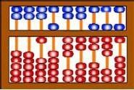
  - People in Asia Minor built a counting device called abacus. This device allowed users to do calculations using a system of sliding beads arranged on a rack. The abacus was simple to operate and was used worldwide for centuries.

Generations of Computers
  - Charles Babbage is known as the father of computer.

  - “Generation” in computer talk is a technology. It provides a framework growth of computer industry.
step in
for the

  - Originally it was used to distinguish between various hardware technologies, but now it has been extended to include both hardware and software
  - Till today, there are five computer generations

First Generation of Computers (1942-1955)
- The first generation computers used very large number of
vacuum tubes for circuitry .
- The input and output medium for first generation computers was the punched card and printout respectively.
- They used Electromagnetic relay memory.
- Stored program concept was used.
- They used Machine language (0 and 1 ) .
- Mostly used for scientific calculations and were costly.
- Bulky in size and highly unreliable.
- Difficult commercial production and difficult to use
- Eg: ENIAC, EDVAC , EDSAC, UNIVAC I and IBM 701

Full Forms

ENIAC
Calculator)
(Electronic Numerical Integrator and

  - EDVAC (Electronic Discrete Variable Automatic Computer).

First Generation Computers

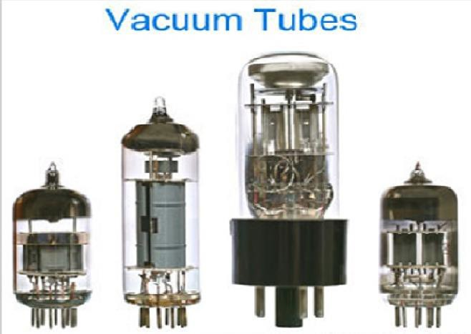

Advantage & Disadvantage
Advantages: Fastest calculating device of their time

Disadvantages:
- Very bulky in size
- Consume a lot of electricity.
- Dissipate a lot of heat.
- Frequently down due to hardware failures.
- Needed constant maintenance because of low mean time between failures.
- Limited commercial use because these computers were difficult to
program.
- Very expensive.

Second Generations of Computer (1955-1964)
  - The main characteristic of these computers was the use of transistors.
  - The input and output medium was the punched card and
printout respectively.
  - At this time, high-level programming languages like COBOL, FORTRAN, ALGOL and SNOBOL were also being developed .
  - They used Batch operating system.
  - They are used for scientific and commercial applications.
  - Faster, smaller, more reliable and easier to program than previous generation systems.
  - Commercial production was still difficult and costly.

Second Generation
  - Eg:- Honeywell 400, IBM 7030, CDC 1604, UNIVAC, LARC

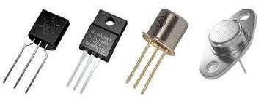

Advantage & Disadvantage
Advantages:
- Consumed less electricity and thus dissipated less heat as compared to first generation computers.
- Faster, cheaper smaller and more reliable than first generation computers.
- Could be programmed using assembly language and high level languages.
- Had faster primary memory and a larger secondary memory.

Disadvantages:
- Second generation computers were manufactured using transistors that had to be assembled manually. This made commercial production of computers difficult and expensive.

Third Generation of Computer (1964-1975)
  - The development of the Integrated Circuit (IC) was the hallmark of the third generation of computers.
  - These computers had few megabytes of main memory and magnetic disks which
could store few tens of megabytes of data per disk drive.
  - High level programming languages like COBOL and FORTRAN were standardized by ANSI.
  - Some more high level programming languages like PL/I PASCAL and BASIC were introduced at this time.
  - Third generation computers were the first to implement time sharing operating systems.
  - Input to these computers could now be provided using keyboards and mouse.

Third Generation
Eg:- IBM 360/370, PDP-8, PDP-11, CDC 6600

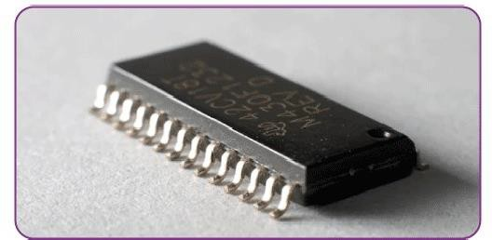

Advantage

Advantages:
- Faster than second generation computers and could perform 1 million transactions per second.
- Smaller, cheaper and more reliable than their predecessors.
3 These computers ha faster and large primary memory and secondary storage.
- Widely used for scientific as well as business applications.
- During this generation of computers, standardization of existing high level languages and invention of new high level languages was done.
- Had time sharing operating system which allowed interactive use of computer by one or more users simultaneously thereby improving the productivity of the users.

Fourth Generation of Computer (1975-1989)
  - The fourth generation of computers with thousands of integrated circuits (IC’s) built onto a single silicon chip named as Very large Scale Integrated Circuits(VLSI)
  - Microprocessors, Semi-conductor memories were used which were very fast, even the hard disks became cheaper, smaller in size and larger in capacity.
  - During this period many new operating systems were developed like MS-DOS MS-Windows, UNIX and Apple’s proprietary operating system.
  - C programming language evolved in this duration.
  - Development of GUIs, the mouse and handheld devices.
  - For secondary storage, Magnetic tapes were used and floppy disks as portable storage media
  - Personal computers and Supercomputers based on parallel vector processing and symmetric multiprocessing technologies.
  - Spread of high-speed computer networks.

Fourth Generation
  - Eg:-IBM PC, Apple II, TRS-80, VAX 9000,CRAY- 1, CRAY-2, CRAY-X/MP

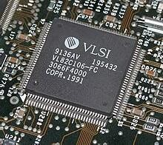
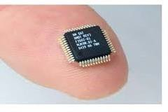

Advantage

Advantages:
- Smaller, cheaper, faster and more reliable .
- Consumed less electricity and therefore dissipated less heat.
- Had faster and larger primary memory and secondary storage.
- Could be used as general purpose computers.
- GUIs enabled people to learn to work with computers very easily. So the use of computers in both office and home became widespread.
- Networks allowed sharing of resources thereby efficient utilization
of computer hardware and software.

Fifth Generation of Computer (1989- Present)
  - ICs with ULSI (Ultra Large Scale Integrated Circuits) technology and are moving towards completely on a new concept of Artificial Intelligence (AI).
(Although such computers are still in development, there are certain applications like voice recognition which is widely being used today.)
  - Larger capacity main memory and hard disks.
  - Optical disks as portable read-only storage media.
  - Notebooks, powerful desktop PCs and workstations
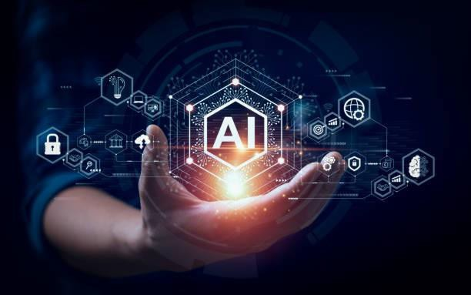
  - Powerful servers, supercomputers.
  - Internet

Fifth Generation Computers

Three characteristics computers are:
    - Parallel Processing
    - Artificial Intelligence
of the fifth generation

Advantage

  - Portable computers.
  - Powerful, cheaper, reliable, and easier to use
machines.
  - Powerful supercomputers.
  - High uptime due to hot-pluggable components.
  - Totally general purpose machines.
  - Easier to produce commercially, easier to upgrade.
  - Rapid software development possible.

desktop

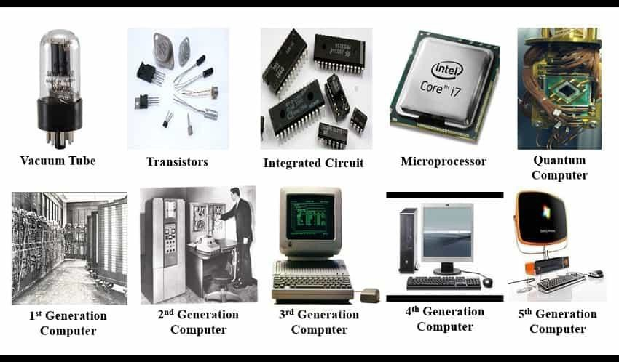

Brief Recap of Generations of
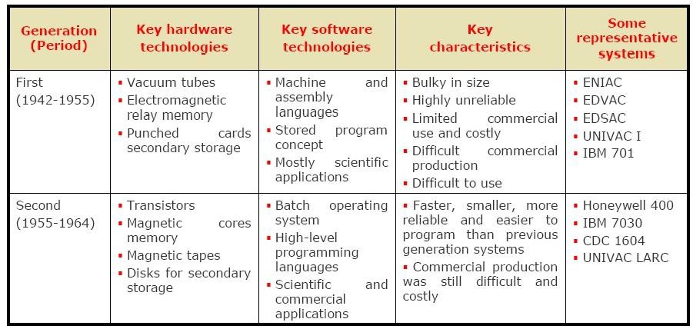
Computer

Recap Contd…

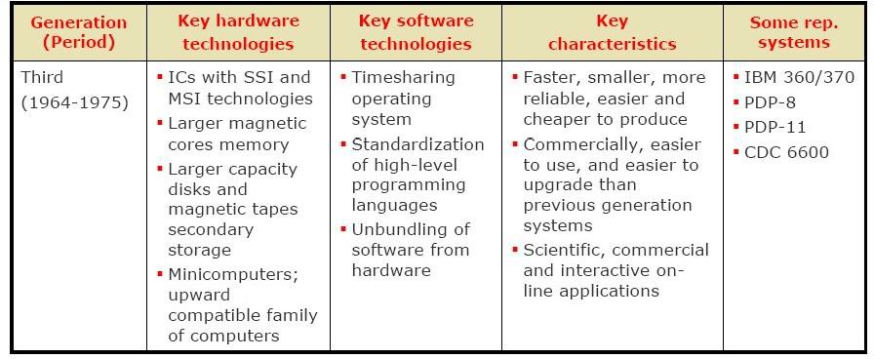

Recap….
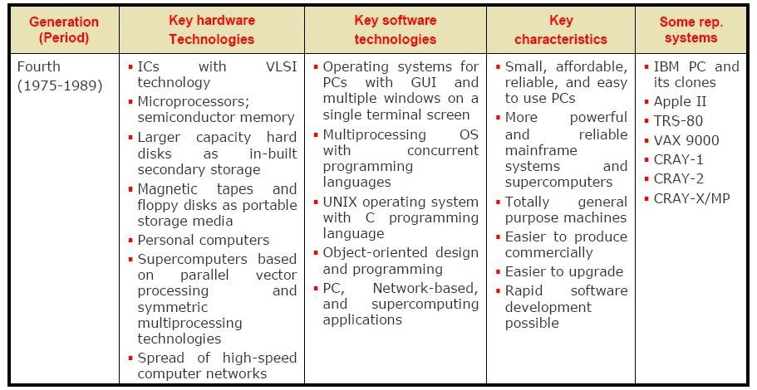

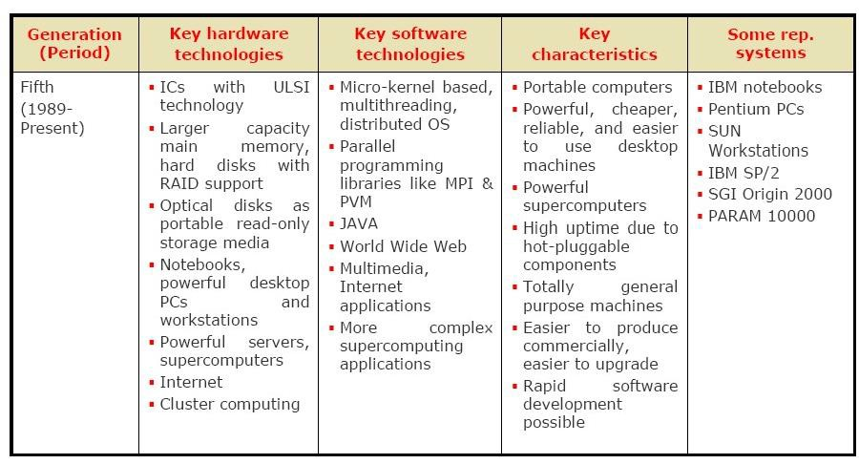
Recap….

Basic Operations Of Computer

A computer is an electronic device which basically performs five major operations which includes:
- Accepts data or instructions (inputting)
- Stores data (Storing)
- Process data (Processing)
- Displays results (output) (Controlling)and
- Controls and co-ordinates all operations inside a computer (Controlling)
OUTPUT
STORAGE
INPUT

Data and instructions
Results

CPU
CONTROL UNIT

Flow of data and instructions Control exercised by control unit
ARITHMETIC
LOGIC UNIT

The Computer System

- A computer can be viewed as a system, which consists of a number of interrelated components that work together with the aim of converting data into information. To attain information, data is entered through input unit, processed by central processing unit (CPU), and displayed through output unit. In addition, computers require memory to process data and store output. All these parts (the central processing unit, input, output, and memory unit) are referred to as the hardware of the computer.

- Any hardware device connected to the computer or any part of the computer outside the CPU and working memory is known as a peripheral. Some examples of peripherals are keyboards, mouse, and monitors.

The Computer System
How Does a Computer Work?
- A computer performs three basic steps to complete any task: input, processing, and output.
- A task is assigned to computer in a set of step-by-step instructions, which is
known as program. These instructions tell the computer what to do with input in order to produce the required output. A computer functions in the following manner:
  - The computer accepts the input. The computer input is whatever entered or fed into a computer system.
  - The computer processes the input data according to the instructions by the user. Examples of processing include calculations, sorting list of words or numbers, etc.
  - The computer produces output. Computer output is the information that has been produced by a computer.

The Computer System
Components of a Computer System

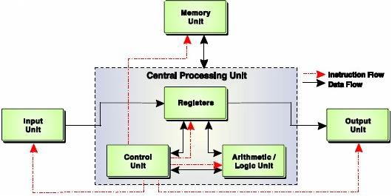

Input Unit

An input unit of a computer system performs the following functions:

- It accepts (or reads) instructions and data from outside
world.
- It converts these instructions and data in computer acceptable form.
- It supplies the converted instructions and data to the computer system for further processing.

Input Devices




Input Devices
Input devices are hardware components used to enter data and commands into a computer. Common input devices include:
- Keyboard - Allows users to input text, numbers, and commands.
- Mouse - A pointing device used to interact with graphical elements on the screen.
- Touchpad - A touch-sensitive surface on laptops used for pointing and scrolling.
- Trackball - A pointing device where the user rolls a ball to move the cursor.
- Scanner - Converts physical documents and images into digital form.
- Microphone - Captures audio input for recording or communication.
- Webcam - Captures video and images for video conferencing or streaming.
- Joystick - Used primarily in gaming and simulations to control movement.
- Digital Pen - Used for writing or drawing on a digital surface, often with a graphics tablet.
- Touch Screen
- MICR (Magnetic Ink Character Recognition)- It is a technology used primarily in banking to read and process paper documents, such as cheques.
- Bar Code Reader
- OCR (Optical Character Recognition)
- Digital Camera

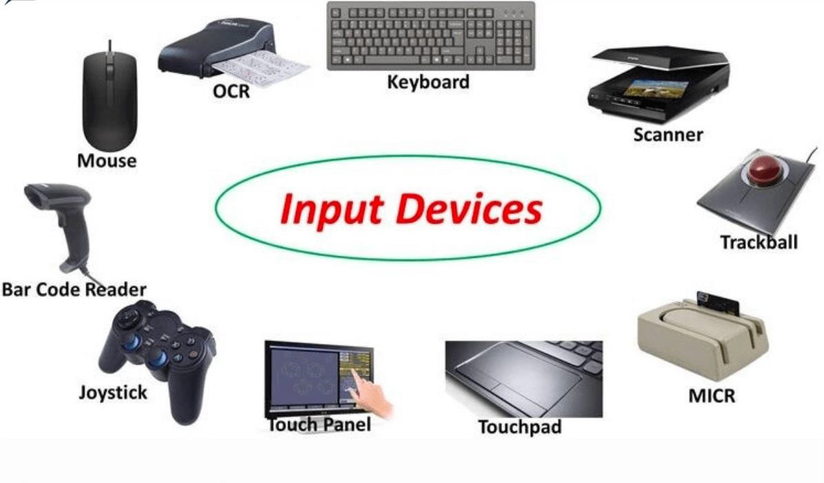

Output Unit
An output unit of a computer system performs the following functions:
- It accepts the results produced by the computer, which are in coded form and hence, cannot be easily
understood by us.
- It converts these coded results to human acceptable (readable) form.
- It supplies the converted results to outside world.

Output Devices

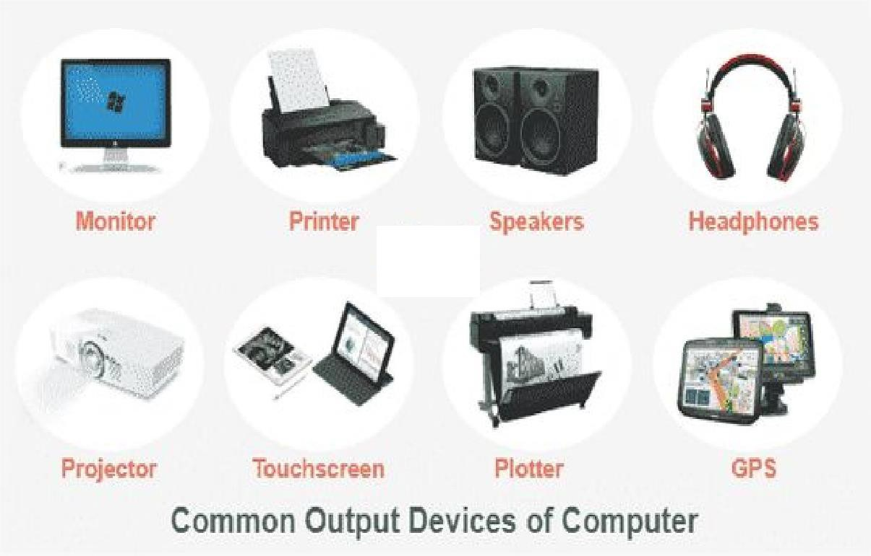

Output Devices
Output devices are hardware components that convey information from a computer to the user. Common output devices include:

- Monitor - Displays visual output, such as the user interface, images, and
videos.
- Printer - Produces hard copies of digital documents, images, and graphics.
- Speakers - Output audio signals, allowing users to hear sound, music, and other audio.
- Headphones - Provide personal audio output for listening to sound without
disturbing others.
- Projector - Projects visual output onto a larger screen or surface, useful for presentations and large displays.
- Plotter - Creates large-scale graphics and detailed drawings, often used in engineering and architecture.

CPU
- The CPU is like the heart/ brain of the computer.
- It is responsible for the processing of all the instructions which are given by the user to the computer system.
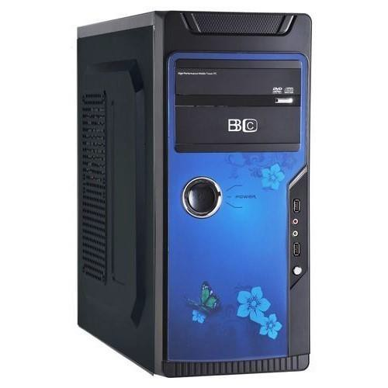
- The CPU is an electronic hardware device which can perform different types of operations such as arithmetic and logical operation.
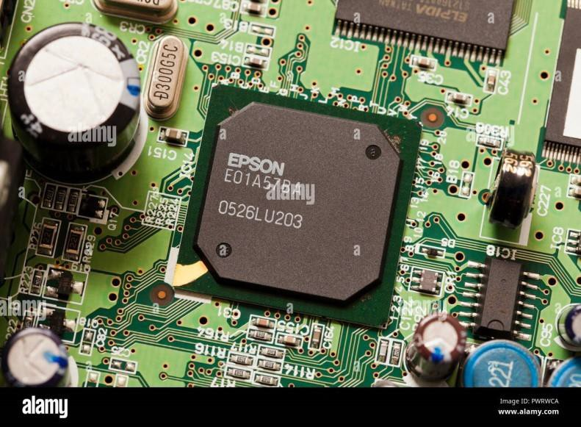

CPU
- It is divided into two parts as:
  - Arithmetic logic unit (ALU) and
  - Control Unit (CU)
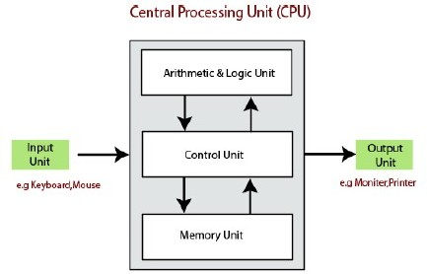

Arithmetic Logic Unit
- Arithmetic and Logical Unit (ALU)
  - The arithmetic and logical unit is the combinational digital electronic circuit that can perform arithmetic operations on integer binary numbers.
  - It presents the arithmetic and logical operation. The outputs of ALU will change asynchronously in response to the input. The basic arithmetic and bitwise logic functions are supported by ALU.

Control Unit
- Control Unit (CU)
  - The control unit (CU) controls all the activities or operations which are performed inside the computer system. It receives instructions or information directly from the main memory of the computer.
  - When the control unit receives an instruction set or information, it converts the instruction set to control signals then; these signals are sent to the central processor for further processing.
  - The control unit understands which operation to execute, accurately, and in which order.

VDU

- VDU | is an abbreviation for | Visual | Display
Unit, | which is a device | that | displays
information from a computer on a screen. It's also commonly known as a computer monitor.

Memory/ Storage Unit

Memory Unit
  - A memory unit is not part of the CPU, but it works closely with
it.
  - The information are stored in the storage/ memory unit of the computer system.
  - The memory unit provides the space to store the data or instruction of processed data.
  - The data storage is the core function and fundamental of the computer components.

* The CPU processes instructions and performs calculations, while the memory unit (often referred to as RAM or Random Access Memory) stores data and instructions that the CPU needs to access quickly.

Memory/ Storage Unit
- Computer memory refers to the electronic holding place for instructions and data where the processor can reach quickly. It can be classified into two broad categories: primary memory (to process the data and hold the intermediate results) and secondary memory (to store the output).
- The primary memory allows the computer to store data for immediate manipulation and to keep track of what is currently being processed. It is volatile. It means that when the power is turned off, the contents of primary memory are lost forever.
- To store the data permanently, a computer requires some non-volatile storage medium like hard disk. This kind of storage is known as secondary memory. It is non-volatile. Such memories store all the data (files) and instructions (computer programs) even after the power is turned off.
- When we talk about memory, we generally refer to the primary memory
only, and when we talk about storage, secondary memory is referred.

Memory Representation

- As we know that digital computers work on only two states: ON (1) and OFF
(0). These two values are represented by two different voltages within the circuit. Each of these values (either 0 or 1) is called a binary digit or bit and can be considered a symbol for a piece of information.

- Various units used to measure computer memory are as follows:

  - Bit: It is smallest unit of data and can hold only one of two values: 0 or 1.
  - Byte: A unit of eight bits is known as a byte.

Memory Representation Contd…
- Kilobyte(KB): A kilobyte is equal to 1024 bytes.
- Megabyte (MB): It comprises 1024 kilobyte
- Gigabyte(GB): It consists of 1024 megabytes and and is the standard unit of measurement for RAM.
- Terabyte (TB): It refers to 1024 gigabytes is the standard unit of measurement for hard disks.
- Petabyte (PB):- It refers to 1,024 terabytes (TB).
- Exabyte(EB): -It is equals to 1024 petabytes.
- Zettabyte(ZB):- It is equals to 1024 exabytes.
- Yottabyte(YB):- It is equal to 1024 zettabytes.
- Brontobyte(BB):- It is equal to 1024 yottabyte.

Memory Hierarchy

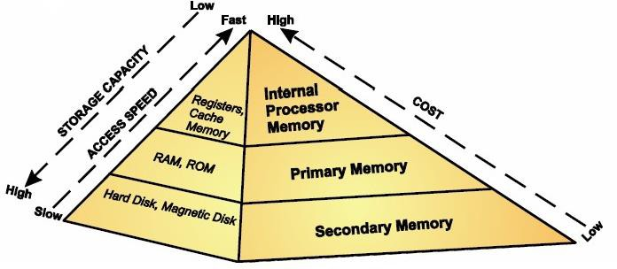

Internal Processor Memory
- Internal process memory usually includes cache memory and registers both of which store data temporarily and are accessible directly by the CPU.

- This memory is placed inside or near the CPU for the fast access of data.

Registers
Registers are high-speed memory locations used for holding instructions, data and intermediate results that are currently being processed. Various types of registers are as follow:

  - PC (Program Counter): This register is used to keep track of the next instruction to be executed.
  - Instruction Register (IR): Holds the current instruction being
decoded and executed.
  - Data Register (DR): Stores data that is being transferred to or from memory.
  - Address Register (AR): Contains the address in memory where data or instructions are stored.
  - Accumulator: This register is used to store the intermediate
results produced by arithmetic and logic units.

Cache Memory
- It is a small, fast and expensive memory that stores the copies of the data that needs to be accessed frequently from the main memory.

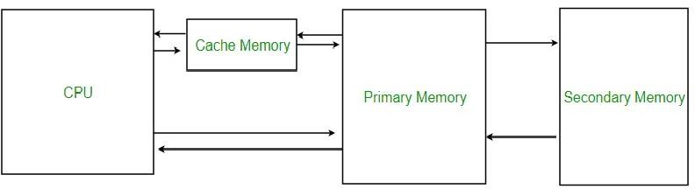

Random Access Memory (RAM)

- RAM allows the computer to store data for immediate manipulation and to keep track of what is currently being processed.

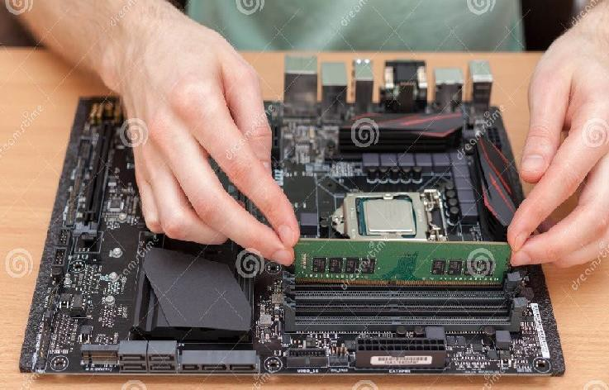
- It is the place in a computer where the operating system, application programs, and data in current use are kept so that they can be accessed quickly by the computer’s processor.
- RAM is much faster to read
from and write to than the other kinds of storage in a computer like the hard disk.

Types Of RAM

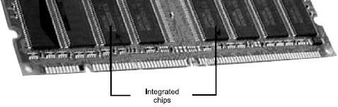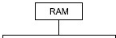

Static Random Access Memory (SRAM)
Static Random Access Memory (SRAM) is a type of random access
memory (RAM) that stores data bits as long as power is supplied:

Working
- SRAM are circuits made of four to six transistors, to store data bits.

Uses
- SRAM is used in a computer's CPU for small amounts of memory called registers and for fast cache memory.
- Differences from DRAM
- SRAM is different from dynamic RAM (DRAM), which must be continuously refreshed. SRAM has better performance and lower power usage than DRAM, but it's also more expensive and requires more space.

Dynamic Random Access Memory (DRAM)
  - DRAM stores the binary information in the form of electric
charges applied to capacitors.
  - The stored information on the capacitors tends to lose over a period of time and thus the capacitors must be periodically recharged/ refreshed to retain their usage.
  - DRAM requires refresh time.
  - The main memory is generally made up of DRAM chips.

SRAM and DRAM
SRAM (Static Random Access Memory) and DRAM (Dynamic Random Access Memory) are both types of volatile memory used in computers, but they have different characteristics, advantages, and uses.

Data Storage Mechanism: SRAM:
  - Stores data using transistors which are stable circuits that do not need to be refreshed. Data is retained as long as power is supplied to the SRAM.

DRAM:
  - Stores data in capacitors. Each cell holds a bit of data as an electric charge in a capacitor.
  - Requires periodic refreshing to maintain the data because the charge leaks away over time.

Speed and Performance: SRAM:
  - Faster than DRAM because it does not need to refresh and has a simpler design for
accessing data.
  - Provides quick access times, which makes it suitable for use in cache memory where speed is critical.

DRAM:
  - Slower compared to SRAM due to the need for refreshing and the more complex access mechanism.
  - Despite being slower, it is still adequate for main memory in most systems.

SRAM and DRAM

Cost:
SRAM: More expensive
DRAM: Less expensive

Power Consumption: SRAM:
  - Generally consumes more power when active due to its complex circuitry but consumes less power in standby mode.
DRAM:
  - Consumes less power per bit compared to SRAM during active use but requires power
for periodic refreshing.
  - Use Cases:
SRAM:
    - Commonly used for cache memory in CPUs (L1, L2, and L3 caches) and other high- speed applications where fast access is essential.
DRAM:
    - Widely used for main memory (RAM) in computers and other devices where large amounts of memory are needed at a lower cost.

Conclusion
- SRAM is faster, more reliable, and more expensive, suitable for applications requiring high speed and quick access times, such as CPU caches.
- DRAM is slower, cheaper, and more dense, making it ideal for main memory where cost and capacity are more critical than speed.
- Both types of memory serve important roles in computing, balancing speed, cost, and capacity according to their intended uses.

Read Only Memory (ROM)
  - ROM is non-volatile in nature, that is, its contents are not lost when the power is switched off.
  - The data and instructions stored in ROM can only be read but cannot be altered thereby making ROM much safer and secure than RAM.
  - ROM performs the necessary BIOS (Basic Input Output System) function.
  - ROM comes in following varieties:

    - Programmable ROM (PROM)
    - Erasable Programmable ROM (EPROM)
    - Electrically Erasable Programmable ROM (EEPROM)
    - Flash ROM

Programmable Read Only Memory (PROM)
- PROM is a memory chip on which the write operation of data can be performed only once.
- The data is stored on this chip permanently, i.e., once a program is written on the PROM, it cannot be erased or destroyed.
- It is mostly used in Product ID Storage.

Erasable Programmable Read-Only Memory(EPROM )
- EPROM can be erased and reprogrammed multiple times
using ultraviolet (UV) light.

- It is used in:
- Firmware Updates where firmware might need periodic updates but not frequently.
- Prototyping: Useful in the development phase for testing and debugging new firmware or software.

EEPROM (Electrically Erasable Programmable Read-Only Memory)
- EEPROM can be erased and reprogrammed electrically.
  - It allows for byte-level erasing and rewriting.
  - It is used in BIOS Chips where system firmware and settings that may need occasional updates.
  - Configuration Data: Used in devices like routers, printers, and industrial equipment to store configuration settings that might need to be changed or updated.

Flash Memory
- It is a type of EEPROM that can be erased and rewritten in larger blocks, with faster access times.
- Applications:
- USB Drives and SD Cards: Used for portable data storage due to its compact size and high capacity.
- SSDs (Solid State Drives): Provides high-speed storage for computers and other devices.

Types of Secondary Storage Devices
  - There are two methods of accessing data from the secondary storage devices: sequential and direct.
  - Based on access secondary storage devices can be classified as:

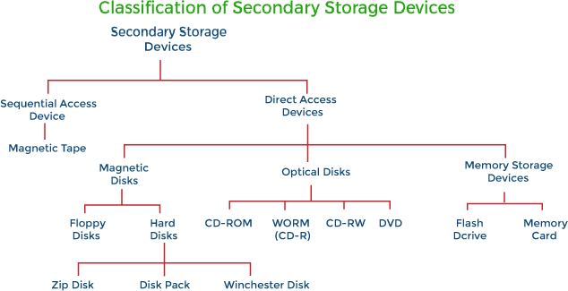

Magnetic Tape


- Magnetic tape looks like the tape used in music cassettes. It is a plastic tape with magnetic coating on it. The data is stored in the form of ti ed and demagnetised portions on the surface of the material.
ny segments of magnetiz

- Advantages of Magnetic Tapes
  - Magnetic tapes are very durable and can be erased as well as reused. They are the least expensive and a reliable storage medium
for organizing archives and taking backups.
  - Magnetic tapes have virtually unlimited storage capacity because as many tapes as required can be used to store a large amount of data.
  - Magnetic tapes are portable because they are compact in size, lightweight, and
- Disardevmaonvtaabglees. of Magnetic Tapes
  - Since magnetic tapes are sequential in nature, they are not suitable in
situations where data access is required in a random order.
  - Since magnetic tapes use parity bit to check the data, the data on such devices are difficult to recover even if a minor bit error occurs.

Magnetic Disk
  - A magnetic disk comprises a thin piece of plastic/metal circular plate/platter, which is coated with magnetic oxide layer. Data is represented as magnetized spots on a disk.
  - To read the data, the magnetized spots on the disk are converted into
electrical impulses, which are then transferred to the processor.
  - The data in a magnetic disk can be erased and reused virtually infinitely. The disk is designed to reside in a protective case or cartridge to shield it from the dust and other external interference.

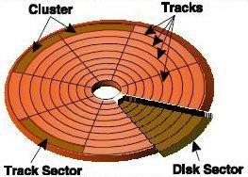

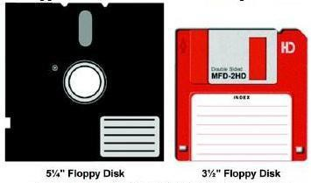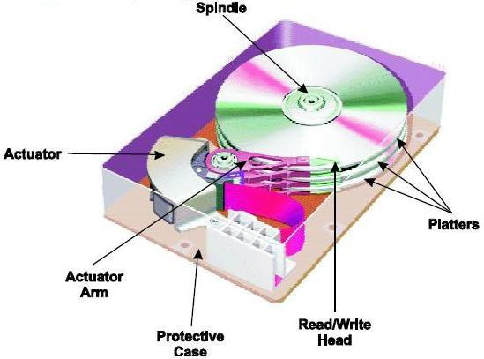Types of Magnetic Disk
  - Floppy Disk: A floppy disk or diskette is a round, flat piece of Mylar plastic coated with ferric oxide (a rust like substance containing tiny particles capable of holding a magnetic field) and encased in a protective plastic cover (disk jacket).

  - Hard Disk: The hard disk, also called the hard drive or fixed disk, is the primary storage unit of the computer. It consists of a stack of disk platters that are made up of aluminium alloy or glass substrate coated with a magnetic material and protective layers.

Optical Disk
- An optical disk is a flat, circular, plastic disk coated with material on which bits may be stored in the form of highly reflective areas and significantly less reflective areas, from which the stored data may be read when illuminated with a narrow-beam source, such as a laser diode.
- These disks are capable of storing enormously high amount of data in a limited
amount of space.
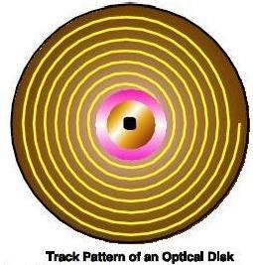

Optical Disk (Contd.)
Types of Optical Disks

Compact Disk (CD)
A CD is a shiny, silver colour metal disk of 12 cm in diameter. A typical optical disk is made up of three layers: a polycarbonate plastic through which light can pass, a layer of aluminium, and a protective layer of acrylic on top of that. Compact disks are available in various formats: CD-ROM (Compact Disk-Read Only Memory), CD-R (Compact Disk-Recordable), and CD-RW (Compact Disk-ReWritable) disks.

Digital Versatile Disk (DVD)
DVD, initially called Digital Video Disk, is high-capacity data storage medium. In DVD, the tracks are placed closer together, thereby allowing more tracks per disk. The DVD’s track pitch (the distance between each) is reduced to 0.74 micron, less than half of CD’s 1.6 micron. The pits, in which the data is stored, are also a lot smaller, thus allowing more pits per track. The minimum pit length of a single layer DVD is 0.4 micron as compared to 0.834 micron for a CD.

Optical Disk (Contd.)

    - Blu-ray Disk
Blu-ray disk is an optical storage device, which is used to record and playback high definition video and audio as well as store images and other data. It uses blue-violet laser having shorter wavelength (405 nm) than a red laser (650 nm) used by DVDs. Due to this shorter wavelength, the laser can be focused more precisely on the small spot thereby resulting in storage capacity ten times than DVD.

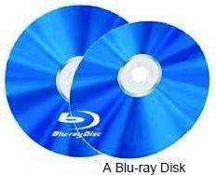

Universal Serial Bus (USB)
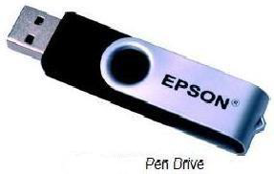
- Pen Drive
A pen/flash drive is a removable storage device that is frequently used nowadays to transfer audio, video, and data files from one computer to another. A pen drive consists of a small printed circuit board, which is fitted inside a plastic, metal, or rubber casing to protect it.

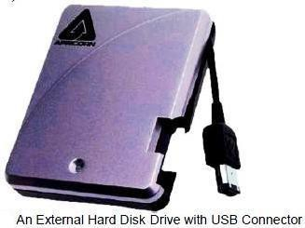
  - External Hard Disk Drive
External hard disk drive is a type of hard drive that resides in its own enclosure (called hard drive cage) outside the computer case and is

connected to the system
interfaces like USB. The
through
storage

capacity of external hard disk ranges from 20 GB to several TBs.

Memory Card
- Memory Card is a digital storage device, which is designed to be used with portable electronic devices such as mobile phone, digital camera, PDA, iPod, etc.
- Though original Memory card provided storage capacity of up to 128 MB,
nowadays Memory Card with storage capacity up to 32 GB is available in the market.
- Nowadays, several different standards or formats of Memory Card are available
in the market.
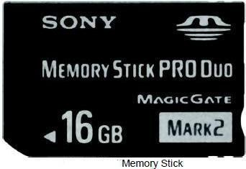

Storage Device Hierarchy

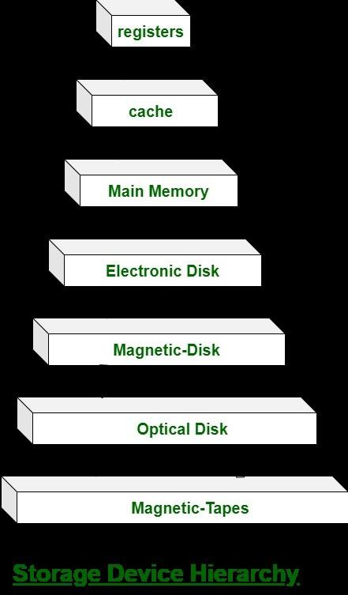

Data, Information & Program
- Data: It is raw details that need to be processed to generate some useful information and is used as input
- Information is processed data useful for the user and is obtained as output of data processing.
- The activity of processing data using a computer is called data processing.
- Program: The set of instructions that can be executed by the computer in sequential or non- sequential manner.

